# Source Control Snapshot(S3)

Link: <https://github.com/profiteroles/RAD>

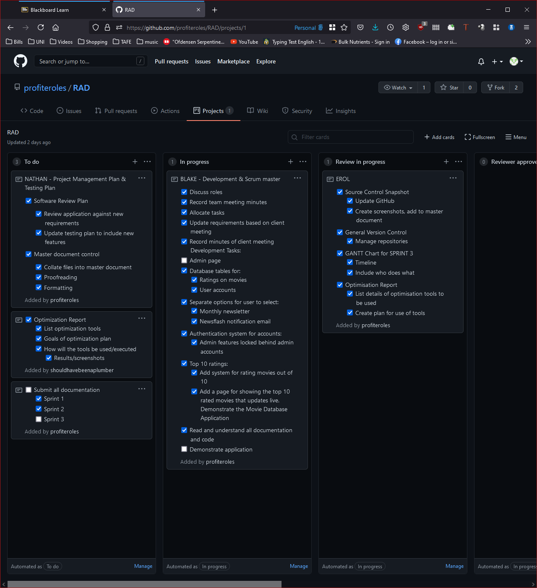

Figure 26- GitHub screenshot

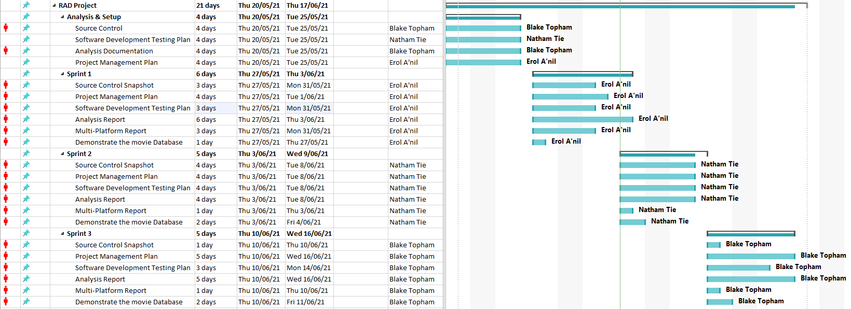

Figure 27- GANTT chart